And the
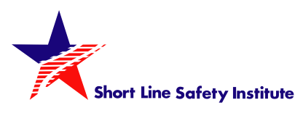
Presents:
Railroad Emergency Preparedness Training
A joint hazardous materials training event for first responders and railroaders combing classroom instruction with hands-on training.
Location: W&LE Railyard – Entrance across from 151 Wabash Ave North Brewster, OH
Date: July 12, 2022
Time: 1800 hrs. – 2200 hrs.
Pizza and drinks will be provided.
This unique training covers:
- Working together under NIMS
- General Safety on Railroad Property
- Safety Considerations at a railroad incident
- Identifying tank car types
- Tank car valves and fittings
- Response plans & site safety plans
- Railcar markings & placards
- Hazard identification & communication
- Tank car anatomy
- Locomotives
There will be two hours of classroom instruction followed by hands-on instruction using the Safety Train. An exercise using scenarios based on local geography and materials handles will follow.

