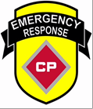
Ice School
February 12-14
Green Bay, WI. 54303

CN & CP Emergency response teams along with the TRANSCAER® Committee will be hosting a Transportation Community Awareness and Emergency Response outreach event.

An 8-hour training class that reviews the strategy and tactics of Response to Environmental Emergencies in waterways during freezing conditions. Classroom instruction followed by hands on evolutions on the ice.

Ice and Rail Safety will be part of this event

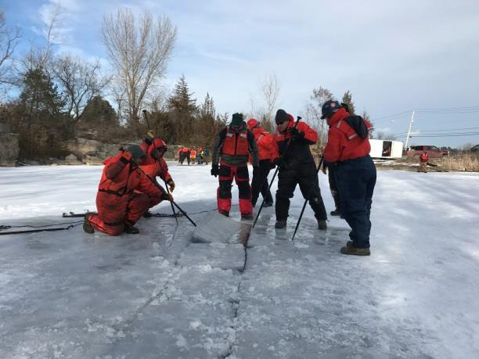
Interactive demonstrations will include:
- CP’s Ice Response/Training Trailer
- Specialized Ice Response Equipment
- Emergency Response equipment

When: Wednesday 12-14
07:30 – Registration
08:00 – 10:00 – Classroom
10:00 – 11:00 – Equipment Demo
11:00 – 12:00 – Lunch
12:00 – 17:00 – Field Demonstration

Where:

Course Content:
- Cold and Frozen Water Oil Spills • Self-Rescue Techniques
- Cold Weather Oil Spill Response PPE • Moving Ice - Spill Response Containment
- Ice Characteristics • Surface and Subsurface Oil Removal
- Source Containment Techniques • Decontamination - Cold Weather Operations

Field Exercise:
- Ice Slotting - Chainsaw • Diversion and Collection
- Ice Slotting - Sled • Trenching

PPE Requirements:

Hard hat
  - Safety glasses
  - Steel toed shoes/boots
  - Work gloves (water proof if possible)
  - Life jackets ( PFD if you have)
  - Appropriate Dress for Weather

There is no cost to attend this event, just your time.

